PRESS INFORMATION

SHARP, BUT NOT DANGEROUS.
THE THREE NEW SAFETY SCISSORS BY MARTOR.
Your press contact:
Jens Augustin
augustin@martor.de
www.martor.com

MARTOR KG
Heider Hof 60
42653 Solingen
Germany

22 July 2014

MARTOR has now expanded its range: with three new safety scissors you can use perfectly for cutting cardboard, paper, plastic film, fabrics and much more – without any risk of harm.

MARTOR is the leading manufacturer of safety knives, the ideal tools for safe and efficient cutting. With the new products SECUMAX 363, SECUMAX 564 und SECUMAX 565 the company from Solingen/Germany transfers its high quality and safety standard to the world of scissors.

The three safety scissors impress with their finger-friendly special grinding which means that the cutting edges are not angled but straight ground. Nevertheless, you can cut through cardboard, paper, film, fabrics, yarn and strapping band very easily. Moreover, the rounded tips help to prevent stab injuries.

Stability and ergonomics count among the major product features as well. The handles of SECUMAX 363, SECUMAX 564 and SECUMAX 565 are made of robust, fiber-glass reinforced plastic; the cutting edges are made of stainless steel. Both of the cutting edges are held together by a real screw fitted in the middle. The comfortable and non-slip soft-grip ensures that the handle lies perfectly in your hand.

The scissors in detail:
The small SECUMAX 363 is suited especially for extra fine and targeted cuts. The lightweight is playfully easy to direct, using your thumb and forefinger only.
The bigger SECUMAX 564 is characterized by its extra-long edge which also serves as an ideal support surface. These safety scissors enable you to work very controlled. Moreover, you need fewer cuts to complete the job.
The strong SECUMAX 565 is in this series the all-purpose tool for professional cutting. Perfect for larger hands – or in case you wear gloves during work. The additional wire-cutter can be used to cut through wires and cables, and the spikes at the handle to open caps.

By the way: You can cut even food and food packaging without any risk as only food safe oil is used.

You can find more information on the home page at www.martor.com

Characters including spaces: 2,061

Product images

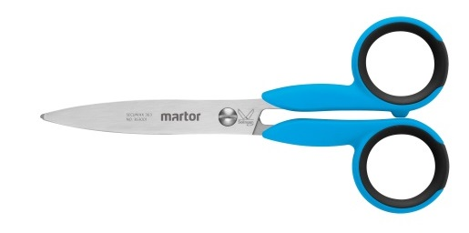
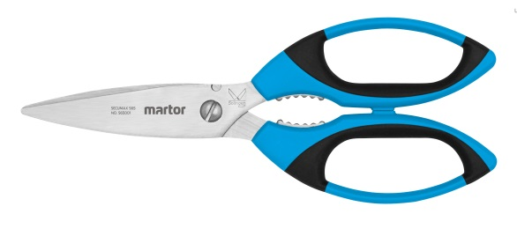
SECUMAX 363 SECUMAX 565
No. 363001 No. 565001

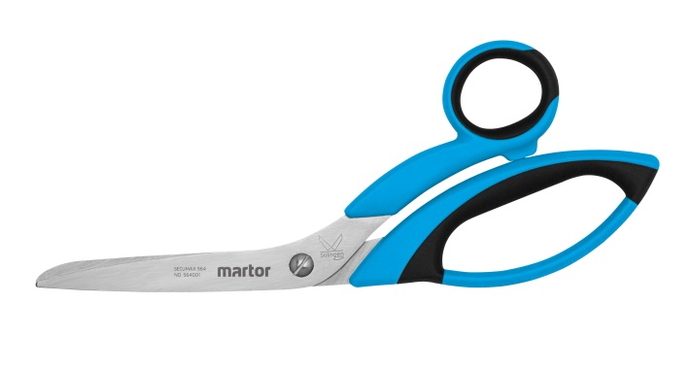
SECUMAX 564
No. 564001

