PRESS INFORMATION

Your press contact:
Jens Augustin
augustin@martor.de
www.martor.com

MARTOR KG
Heider Hof 60
42653 Solingen
Germany

01 April 2015

MARTOR SUCCESSFUL IN THE RED DOT AWARD 2015:
SECUNORM 380 AND SECUMAX 350 AWARDED FOR HIGH DESIGN QUALITY.

SECUNORM 380 and SECUMAX 350 from MARTOR KG in Solingen/Germany won over the 38-member jury of the Red Dot Award: Product Design 2015. With its safety knives, MARTOR proved its design excellence in the most important competition for product design, which is celebrating its 60th anniversary this year.

The international experts discussed and assessed each of the 4,928 entries from 56 countries. But only the designs that won over the jury with their quality and innovative power were given an award. SECUNORM 380 and SECUMAX 350 from MARTOR succeeded in convincing the jury members, deservedly winning the sought-after Red Dot seal of quality. Throughout the world and across different industries, Red Dot is seen as the award for high design quality. The international Red Dot jury bestows the sought-after seal of quality only to those products that stand out clearly from comparable entries thanks to their excellent design.

The winning products
After winning the pro-K award, which is yearly awarded for outstanding plastic products, the Red Dot Design Award means the second important honour for the SECUMAX 350 this spring. The SECUMAX 350 combines versatility, comfort and a maximum degree of safety. With its concealed blade it can be used to cut all standard materials, from film to plastic-strapping, from paper to 2-ply cardboard. Furthermore, the 37 grams light safety knife features an innovative blade change. The new SECUNORM 380, on the other hand, won this price right in time for the official market launch. It is the first safety knife worldwide featuring a blade extension length of almost 8 cm and automatic blade retraction. In short, it’s the safe alternative to all conventional fixed blade cutters. Besides, the SECUNORM 380 is an excellent example for the MARTOR product policy to bring form and function in harmony.

Professor Dr Peter Zec, Founder and CEO of the Red Dot Award: “For 60 years, the most-respected design experts have been convening every year in Essen to seek out the best designs. This year we had a record number of almost 5,000 entries – a huge amount of work for our jury members, who assessed each individual product, and a special value of the distinction due to the high standard. The laureates of the Red Dot Award: Product Design 2015 have demonstrated exceptionally high achievements and have thus been deservedly successful in the world’s largest design competition.”

Red Dot Gala
The internationally respected product competition will culminate in the Red Dot Gala in Essen on 29 June 2015. The award ceremony with more than 1,200 guests will be hosted by Professor Dr Peter Zec in Essen’s Aalto-Theater. At the subsequent Designers’ Night after-show party, the winners celebrate in the midst of award-winning products in the Red Dot Design Museum Essen. The winning products are then presented for four weeks in the special exhibition “Design on Stage” before being included in the museum’s permanent exhibition.

Red Dot Design Museum Essen
With roughly 2,000 exhibits over 4,000 square metres, the Red Dot Design Museum presents the world’s largest exhibition of contemporary design. The successful entries in the Red Dot Award: Product Design 2015 will be shown from 29 June to 26 July 2015 in an impressive special exhibition in the midst of the historical industrial architecture of the Zollverein World Heritage site. In “Design on Stage”, visitors will experience the current top achievements up close and personal, because this hands-on exhibition expressly encourages visitors to touch and try out the exhibits. In this way, fans of design can find out about the trends in international product design and see for themselves the good quality of the safety knives from MARTOR.

About the Red Dot Award
In order to appraise the diversity in the field of design in a professional manner, the Red Dot Design Award breaks down into the three disciplines of Red Dot Award: Product Design, Red Dot Award: Communication Design and Red Dot Award: Design Concept. The Red Dot Award was created by Design Zentrum Nordrhein Westfalen and with around 17,000 entries each year is one of the best-respected design competitions in the world. In 2015, it is celebrating its 60th anniversary: It was in 1955 that a jury convened for the first time to assess the best designs of the day. The sought-after award, the “Red Dot”, is the revered international seal of outstanding design quality. Award-winning designers, manufacturers and agencies use the Red Dot winner label and receive numerous other winners’ privileges, such as the presentation of the award-winning product on Red Dot Online, in the Red Dot Design Yearbook, the Red Dot App and on Red Dot 21. Additionally, the winning products are communicated in the international PR activities of Red Dot and exhibited in the Red Dot Design Museum Essen for a whole year.

You can find more information on our homepage, www.martor.com, or at www.red-dot.org/press.

Characters including spaces: 5,058

Press contact at Red Dot:
Catharina Hesse
Communications Manager
Design Zentrum Nordrhein Westfalen
Gelsenkirchener Str. 181
45309 Essen
Germany
Tel.: +49-201-30104-50
c.hesse@red-dot.de
www.red-dot.org/press

Product image

SECUNORM 380
No. 380001
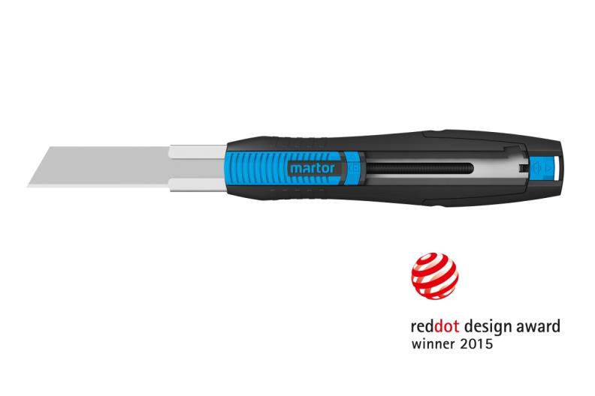

Product image

SECUNORM 350
No. 350001
