PRESS INFORMATION

Your press contact:
Jens Augustin
augustin@martor.com
www.martor.com

MARTOR KG
Heider Hof 60
42653 Solingen
Germany

14 March 2016

WHAT WINNERS ARE MADE OF.
TWO PRIZES FOR MARTOR AT iF AWARD 2016.

MARTOR remains unstoppable at winning international design competitions. The knife manufacturer from Solingen has also been victorious with its SECUMAX 350 and SECUNORM 380 at the iF DESIGN AWARD 2016.

The two safety knives SECUMAX 350 and SECUNORM 380 won their prizes in the top "Product" discipline. The jury decided mainly on design quality but also took product values into account such as craftsmanship, level of innovation, environmental friendliness and functionality. This was the fourth award in a row for the SECUMAX 350 following the red dot design award 2015, the pro-K Award 2015 and the German Design Award 2016, and the third for the SECUNORM 380 (following the red dot and the German Design Awards).

For more than 60 years, the iF DESIGN AWARD has been one of the world's most well-known trademarks and one of the most renowned prizes for exceptional product design. Prize winners in 2015 included BMW, DAIMLER, SAMSUNG, APPLE, SIEMENS, BRAUN, HILTI and CANON.

2016 again witnessed a mass of nominations for the awards. The 58 international members of the expert jury had to choose winners from more than 5000 submissions from 53 countries in seven award disciplines (which included "Product", "Packaging" and "Architecture").

The iF Award was presented at the BMW Welt in Munich.

Further information is available from www.martor.com.

Characters including spaces: 1,413

Product images

SECUNORM 380
NO. 380001

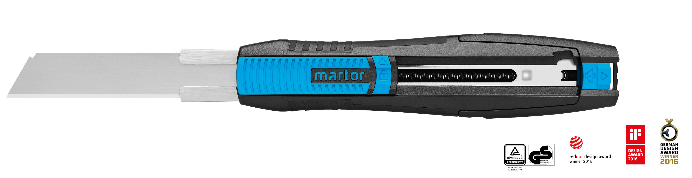

SECUMAX 350
NO. 350001

