PRESS INFORMATION

Your press contact:

Jens Augustin

augustin@martor.de

www.martor.com

MARTOR KG

Lindgesfeld 28

42653 Solingen

Germany

2 March 2020

**STEEL OR CERAMIC BLADES?**

**YOU NOW HAVE THE CHOICE WITH MARTOR.**

**The Solingen-based company MARTOR, internationally leading manufacturer and supplier of safety knives, is expanding its range of blades with three new high-quality ceramic blades. These can be used in existing MARTOR knife handles giving customers flexibility while also extending their knives' range of uses.**

**Greater flexibility for customers**

MARTOR customers have always enjoyed plenty of choice to carry out cutting tasks safely. For example, choices between universal and special knives, between aluminium and plastic handles, or between knives with different types of safety technology.

A new dimension has now been added:ceramic blades. These give flexibility in the choice between using either steel or ceramic blades. Both types of blade fit precisely into existing MARTOR handles.

This means customers, when cutting with the new ceramic blade, remain protected by the MARTOR safety technology already in their safety knife. They will also still have the comfort and ergonomics provided by MARTOR's tried and tested handles.

**Special properties in MARTOR ceramic blades**

MARTOR is initially launching its new ceramic range with three blades: the two trapezoidal blades NO. 60099C and NO. 65232C and the rectangular blade NO. 92C.

MARTOR ceramic blades are made of high-quality zirconium oxide, are very sharp and stay sharp. This makes them ideal for a wide range of cutting materials, from 2-ply cardboard and film through to adhesive tape. They have a 12 times longer service life than comparable steel blades therefore significantly reducing the need for blade changing.

Ceramic blades also have special chemical and physical properties, e.g. non-rusting, non-conductive, chemically stable, etc., to make them ideal for cutting under special conditions and further extending the range of uses of MARTOR safety knives.

Characters including spaces: 1,883

**Product images**

CERAMIC BLADE NO. 92C CERAMIC BLADE NO. 60099C

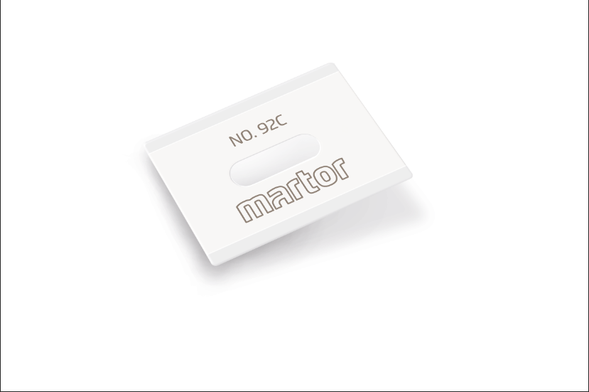 Ein Bild, das Visitenkarte enthält.

CERAMIC BLADE NO. 65232C Example of use:

Ein Bild, das Visitenkarte enthält.
