PRESS INFORMATION

Your press contact:
Jens Augustin
augustin@martor.de
www.martor.com

MARTOR KG
Lindgesfeld 28
42653 Solingen
Germany

June 25, 2021

SAFETY KNIVES WITH CERAMIC BLADES.
MARTOR LAUNCHES NEW KNIFE FAMILY.

The Solingen-based company MARTOR is renowned for its high-quality and innovative safety knives. Six of these are now also available with pre-installed ceramic blades. The new product family is aimed at professional users who want durable blades with long-lasting sharpness.

MARTOR's new offering includes the SECUPRO MERAK, SECUPRO MARTEGO and SECUPRO MAXISAFE safety knives on the one hand, and SECUNORM MIZAR, SECUNORM 500 and SECUNORM 525 on the other. To protect against cutting injuries, all SECUPRO knives are equipped with fully automatic blade retraction, and all SECUNORM knives with automatic blade retraction.

The six safety knives already rank among MARTOR's top products. They are equipped as standard with high-quality steel blades, with ceramic blades previously "only" available as optional spare blades. This option remains. The new feature is that customers can now receive their MARTOR ceramic blade knife fully assembled "ex works".

This includes the perfected MARTOR handle with dependable safety technology, ergonomic shape and comfort handling – and a ceramic blade that lasts up to 12x longer than a comparable steel blade and remains very sharp for a very long time. All in all, this results in particularly high cutting performance with very infrequent blade changing.

MARTOR ceramic blades also have special chemical and physical properties including being non-rusting, non-conductive, chemically stable, etc. This makes them ideal for cutting under special environmental conditions, which further expands the range of applications for the six MARTOR ceramic blade knives.

Characters including spaces: 1,665

Press photo

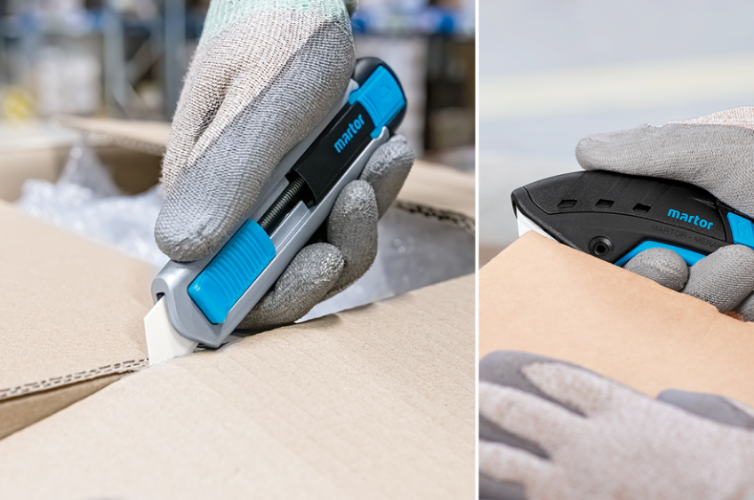

(SECUNORM 525 + SECUPRO MERAK)

